**Carbohydrates**

* The name "carbohydrate" means a "hydrate of carbon.“
* The name is derived from the general formula of carbohydrate is Cx(H2O)y-x and y may or may not be equal and range in value from 3 to 12 or more
* For example glucose is: C6(H2O)6 or is more commonly written, C6H12O6.
* General names for carbohydrates include sugars, starches, saccharides, and polysaccharides. The term saccharide is derived from the Latin word " saccharum" from the sweet taste of sugars.
* The chemistry of carbohydrates most closely resembles that of alcohol, aldehyde, and ketone functional groups. As a result, the modern definition of a CARBOHYDRATE is that the compounds are polyhydroxy aldehydes or ketones.
* The chemistry of carbohydrates is complicated by the fact that there is a functional group (alcohol) on almost every carbon. In addition, the carbohydrate may exist in either a straight chain or a ring structure. Ring structures incorporate two additional functional groups: the hemiacetal and acetal.
* A major part of the carbon cycle occurs as carbon dioxide is converted to carbohydrates through photosynthesis. Carbohydrates are utilized by animals and humans in metabolism to produce energy and other compounds.

**Synthesis**

* Carbohydrates are initially synthesized in plants from a complex series of reactions involving photosynthesis.

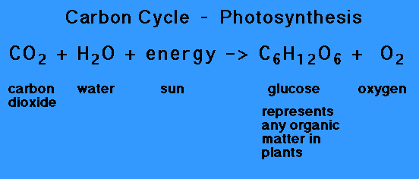

* Photosynthesis is a complex series of reactions carried out by algae, phytoplankton, and the leaves in plants, which utilize the energy from the sun
* The simplified version of this chemical reaction is to utilize carbon dioxide molecules from the air and water molecules and the energy from the sun to produce a simple sugar such as glucose and oxygen molecules as a by product.

**Biological functions**

* Store energy in the form of starch (photosynthesis in plants) or glycogen (in animals and humans).
* Provide energy through metabolism pathways and cycles.
* Supply carbon for synthesis of other compounds.
* Form structural components in cells and tissues.
* intermediates in the biosynthesis of other basic biochemical entities (fats and proteins)
* associated with other entities such as glycosides, vitamins and antibiotics)
* form structural tissues in plants and in microorganisms (cellulose, lignin, murein)
* participate in biological transport, cell-cell recognition, activation of growth factors, modulation of the immune system

**Classification of Carbohydrates**

* Based on the location of C=O functional group (aldehyde C=O or ketone C=O)
* number of carbon atoms
* Number of sugar units
* Stereochemistry

**Classification based on the number of sugar units**

* Monosaccharides - simple sugars with multiple OH groups ;simplest carbohydrate that cannot be broken down into smaller carbohydrate molecules
* Disaccharides - 2 monosaccharides covalently linked.
* Oligosaccharides - a few monosaccharides covalently linked, more specifically 10 monomers
* Polysaccharides - polymers consisting of chains of monosaccharide or disaccharide units

Monosaccharides

* Classification based on C=O functionality
* Aldoses (e.g., glucose) have an aldehyde group at one end.

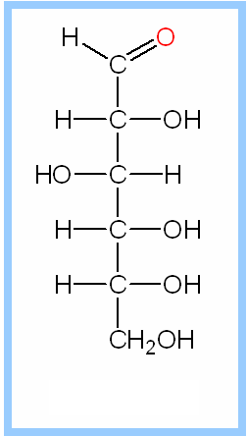

Ketoses (e.g., fructose) have a keto group, usually at C2.

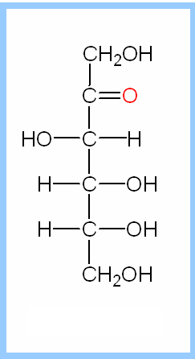

Monosaccharide

* Classification based on number of Carbon atom

**Classification based on C=O functionality**

**Aldoses**

* **D-glyceraldehyde**-product of breakdown of larger monosaccharides
* **D-erythrose and threose** are not abundant in nature,
* **D-erythrose** can be found in muscles of animals in minimum amount in form of its derivative erythrose-4-phosphate
* **D ribose**-component of RNA
* **D xylose and arabinose** can be found in nuts.
* **D xylose** is sugar that is normally not metabolized is used to detect carbohydrate malabsorption in the xylose excretion test
* **D-2-deoxyribose** is another aldopentose similar to that of ribose
* Structure of D-ribose and D-2-Deoxyribose are identical except that there is a hydrogen atom instead of hydroxyl group in C-2 carbon atom of D-2-Deoxyribose
* **Deoxyribose** is a component of deoxyribosenucleic acid (DNA), a compound which transmits genetic information from parent to offspring by directing the synthesis of protein molecules

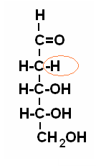

* **D-glucose**-a white crystalline solid found in the fruit juice and honey and in blood of mammals
* D-glucose is also known as grape sugar and blood sugar (dextrose)
* Deficiency in insulin in the body results in increase in blood sugar level. Disorder related in the insufficient production of insulin in the body is known as diabetes mellitus
* **D-galactose**-important monosaccharide that can combined with glucose in the disaccharide lactose, a component of milk.
* Galactosemia-congenital disorder,a persons who are suffering on this disease are unable to metabolize galactose because they lack enzymes that can degrade galactose.

**Classification based on C=O functionality**

**Ketoses**

* D-fructose is the most important ketose in living organisms
* D-frucose-known as fruit sugar and considered as the sweetest tasting sugar. Also known as the levulose because it rotates the plane polarized light levorotatorily

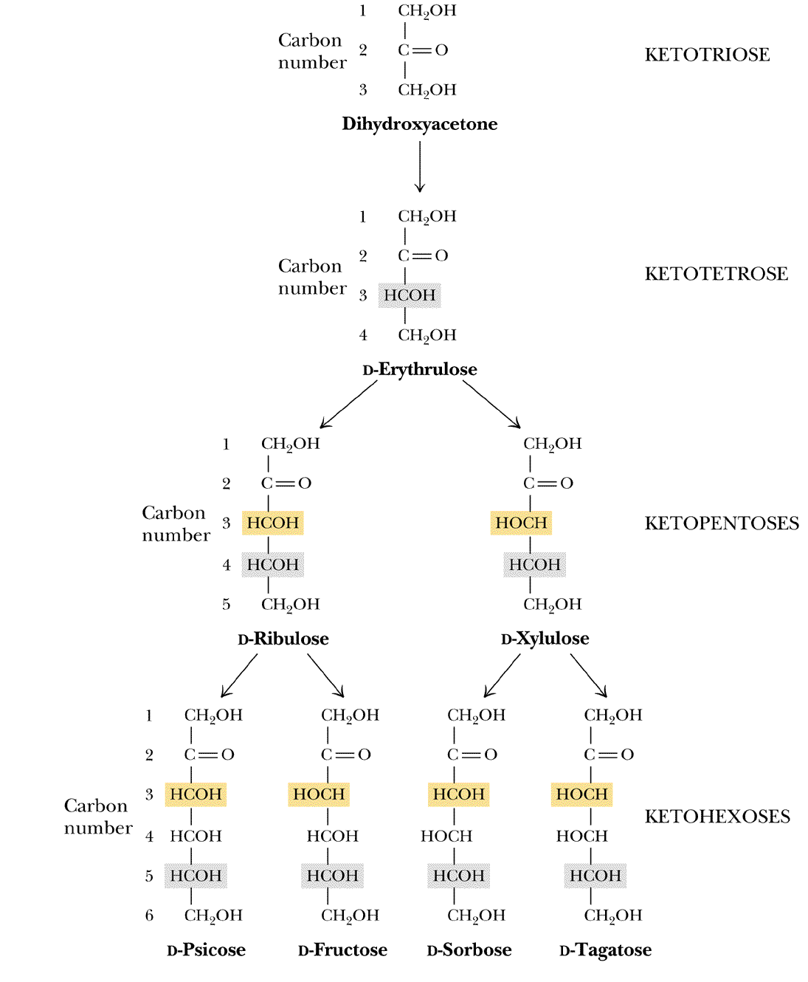

**Types of stereoisomerisms exhibit by carbohydrate molecules**

* **Enantiomers**- a special class of stereoisomers which are not superimposable mirror image of each other. The two enantiomers of a compound have the identical chemical properties but differ in characteristic physical property, ability to rotate the plane of plane polarized light. Rotation of plane of plane polarized light are clockwise (dextrorotatory, positive rotation, +) or counterclockwise (levorotatory, negative, -) rotation

Compounds posses enantiomeric property if it:

-contain chiral or asymmetric carbon center (4 different groups are attached to central carbon atom

-mirror image of one another

-not superimposable

**Enantiomers**

Consider glyceraldehyde

* There is only one asymmetric C atom in glyceraldehyde which can be found in C-2
* Using the formula 2n,the number of possible stereoisomers can be calculated, where n is the number of asymmetric C-atom
* Since there is only one asymmetric C-atom, the possible number of stereoisomer is only 2, the dextrorotatory and levorotatory stereoisomer

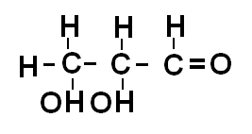

* For glyceraldehyde, using the Fischer projections, the 2 stereoisomers are shown below

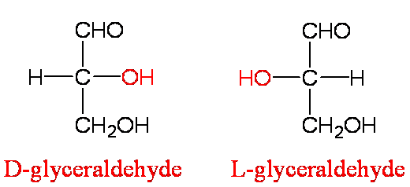

**Epimer**

* Epimer-molecules differ only in position of one OH group

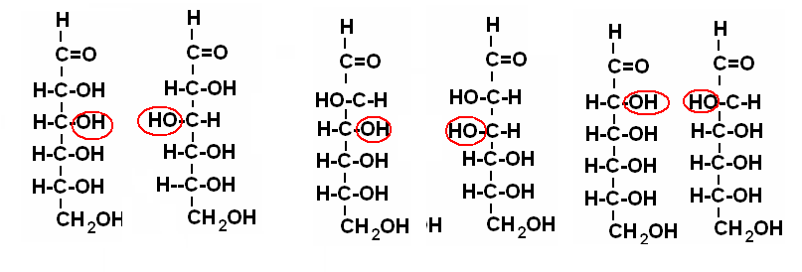

**Structural representation of sugars**

* Fisher projection: straight chain representation
* Haworth projection: simple ring in perspective
* Conformational representation: chair and boat configurations

**Aldohexose: Pyranoses**

* Open chain monosaccharides form cyclic hemiacetals or hemiketals when an H atom from the hydroxyl group adds to the carbonyl group. A new single bond forms between the Hydroxyl O and the Carbonyl C
* Anomers-isomers of sugar differ only in the anomeric position of OH
* Alpha and beta anomer

**Cyclic Structure for Glucose**

Glucose cyclic hemiacetal formed by reaction of -CHO with -OH on C5.

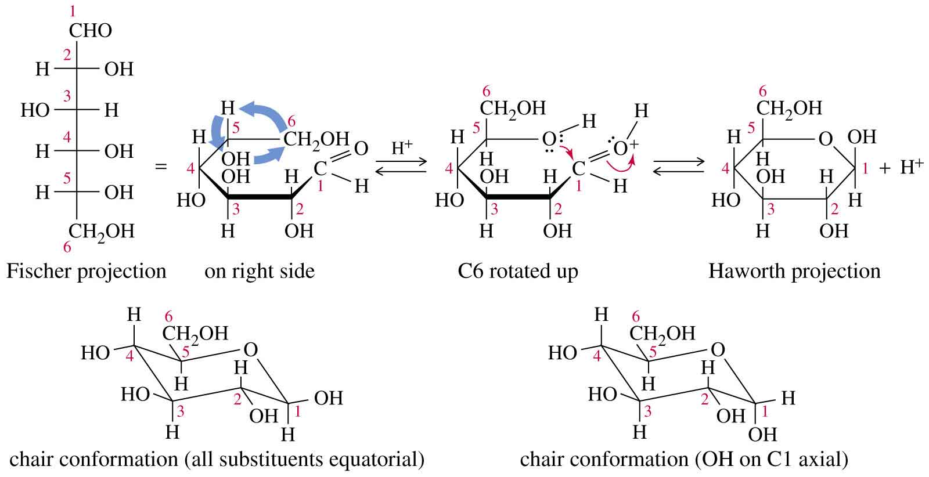

Glucose forms an intra-molecular hemiacetal, as the C1 aldehyde & C5 OH react, to form a 6-member pyranose ring, named after pyran.



Cyclization of glucose produces a new asymmetric center at C1. The 2 stereoisomers are called anomers, a & b.

Haworth projections represent the cyclic sugars as having essentially planar rings, with the OH at the anomeric C1:

* + α (OH below the ring)
  + β (OH above the ring).



Because of the tetrahedral nature of carbon bonds, pyranose sugars actually assume a "chair" or "boat" configuration, depending on the sugar.

The representation above reflects the chair configuration of the glucopyranose ring more accurately than the Haworth projection.

Aldopentoses and Ketohexoses: Furanoses

* The cyclic forms of aldopentoses and ketohexoses both contain five membered rings that include 4 carbon atoms and one O atom. To produce the hemiacetal form of an aldopentose, the hydroxyl H atom on the C-4 atoms adds to the carbonyl.
* Pentoses and hexoses can cyclize as the ketone or aldehyde reacts with a distal OH.

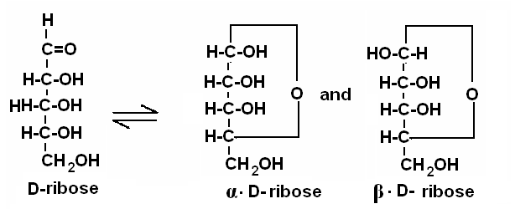

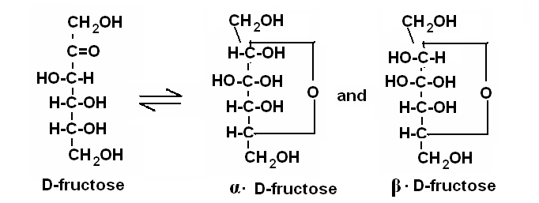

**Cyclic Structure for Fructose**

Cyclic hemiacetal formed by reaction of C=O at C2 with -OH at C5.

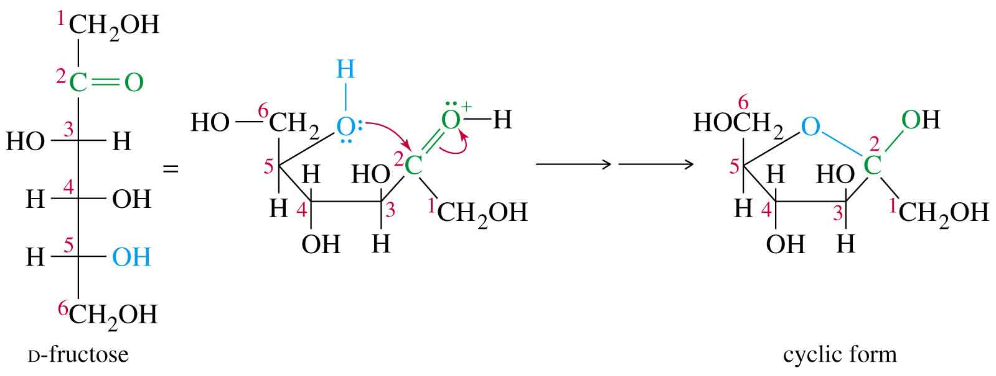

**Glycosidic Bonds**

The anomeric hydroxyl and a hydroxyl of another sugar or some other compound can join together, splitting out water to form a glycosidic bond:

R-OH + HO-R' 🡪 R-O-R' + H2O

E.g., methanol reacts with the anomeric OH on glucose to form methyl glucoside (methyl-glucopyranose).



**Disaccharides**

**Maltose,** a cleavage product of starch (e.g., amylose), is a disaccharide with an a(1® 4) glycosidic link between C1 - C4 OH of 2 glucoses.

It is the a anomer (C1 O points down).



**Sucrose** (common name: table sugar, also called saccharose) is a disaccharide (glucose + fructose) with the molecular formula C12H22O11. Its systematic name is α-D-glucopyranosyl-(1→2)-β-D-fructofuranose. It is best known for its role in human nutrition and is formed by plants but not by higher organisms

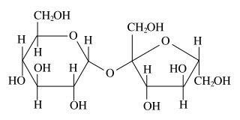

**Lactose** is a disaccharide that consists of β-D-galactose and β-D-glucose molecules bonded through a β1-4 glycosidic linkage. Lactose makes up around 2-8% of the solids in milk. The name comes from the Latin word for milk, plus the -ose ending used to name sugars.

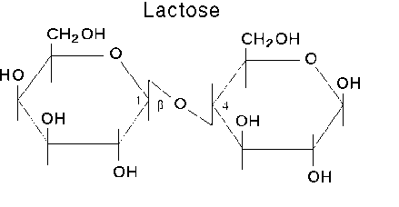

**Trehalose**, also known as *mycose*, is an alpha-linked (disaccharide) sugar found extensively but not abundantly in nature. It can be synthesized by fungi, plants and invertebrate animals. It is implicated in anhydrobiosis—the ability of plants and animals to withstand prolonged periods of desiccation.

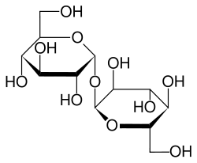

* The sugar is thought to form a gel phase as cells dehydrate, which prevents disruption of internal cell organelles by effectively splinting them in position. Rehydration then allows normal cellular activity to be resumed without the major, generally lethal damage, that would normally follow a dehydration/rehydration cycle. Trehalose has the added advantage of being an antioxidant.

**Cellobiose** is a disaccharide subunit of cellulose composed of two glucose molecules linked in a β(1→4) bond; which can be hydrolyzed by bacteria or cationic exchangers. Cellobiose is an indispensable part of fabric especially cotton, jute, and other cellulosic material.

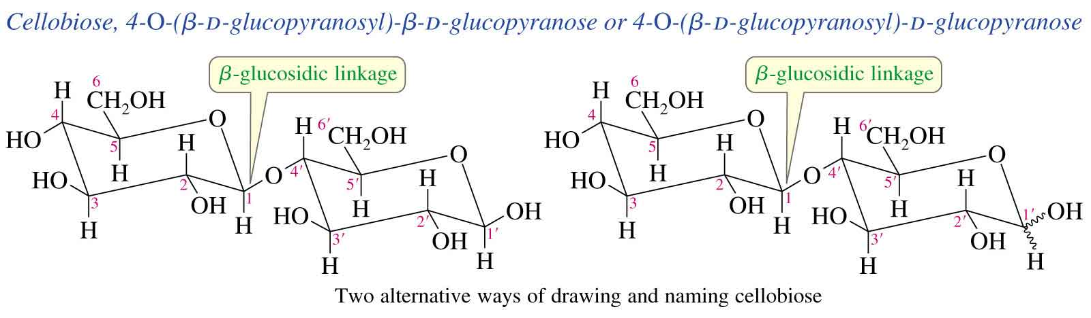

* Cellobiose is also an essential part of all plant structures. Its strong -OH bond interactions with neighboring cellobiose molecules contributes greatly to the plant's structural resilience. Most mammal do not possess the enzyme needed to break down cellobiose into useable energy but some insects such as termites possess the needed enzyme.

**Lactulose**

* galactose-b-(1,4)-fructose
* a semi-synthetic disaccharide (not naturally occurring)
* not absorbed in the GI tract
* used either as a laxative (Chronulac) or in the management of portal systemic encephalopathy (Cephulac)
* metabolized in distal ileum and colon by bacteria to lactic acid, formic acid and acetic acid (remove ammonia)

**Oligosaccharides**

* Trisaccharide: raffinose (glucose, galactose and fructose)
* Tetrasaccharide: stachyose (2 galactoses, glucose and fructose)
* Pentasaccharide: verbascose (3 galactoses, glucose and fructose)
* Hexasaccharide: ajugose (4 galactoses, glucose and fructose)

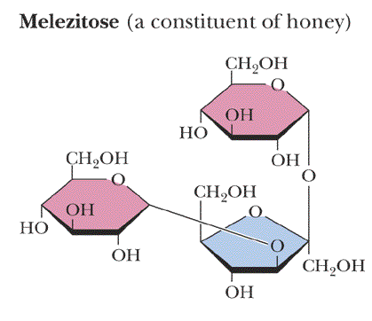

**Polysaccharides or glycans**

* **homoglycans** (starch, cellulose, glycogen, inulin)
* **heteroglycans** (gums, mucopolysaccharides)
* characteristics:
  + - polymers (MW from 200,000)
    - White and amorphous products (glassy)
    - not sweet
    - not reducing; do not give the typical aldose or ketose reactions)
    - form colloidal solutions or suspensions

**Starch**

* most common storage polysaccharide in plants
* composed of 10 – 30% a-amylose and 70-90% amylopectin depending on the source
* the chains are of varying length, having molecular weights from several thousands to half a million

**Amylose**

* Soluble starch, polymer of D-glucose.
* Starch-iodide complex, deep blue.

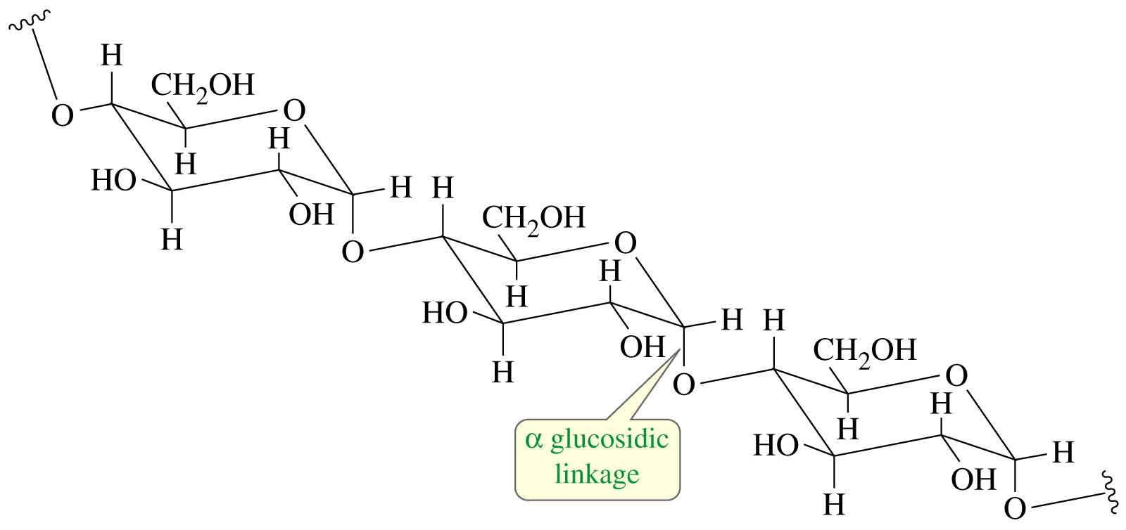

**Amylopectin**

Branched, insoluble fraction of starch.

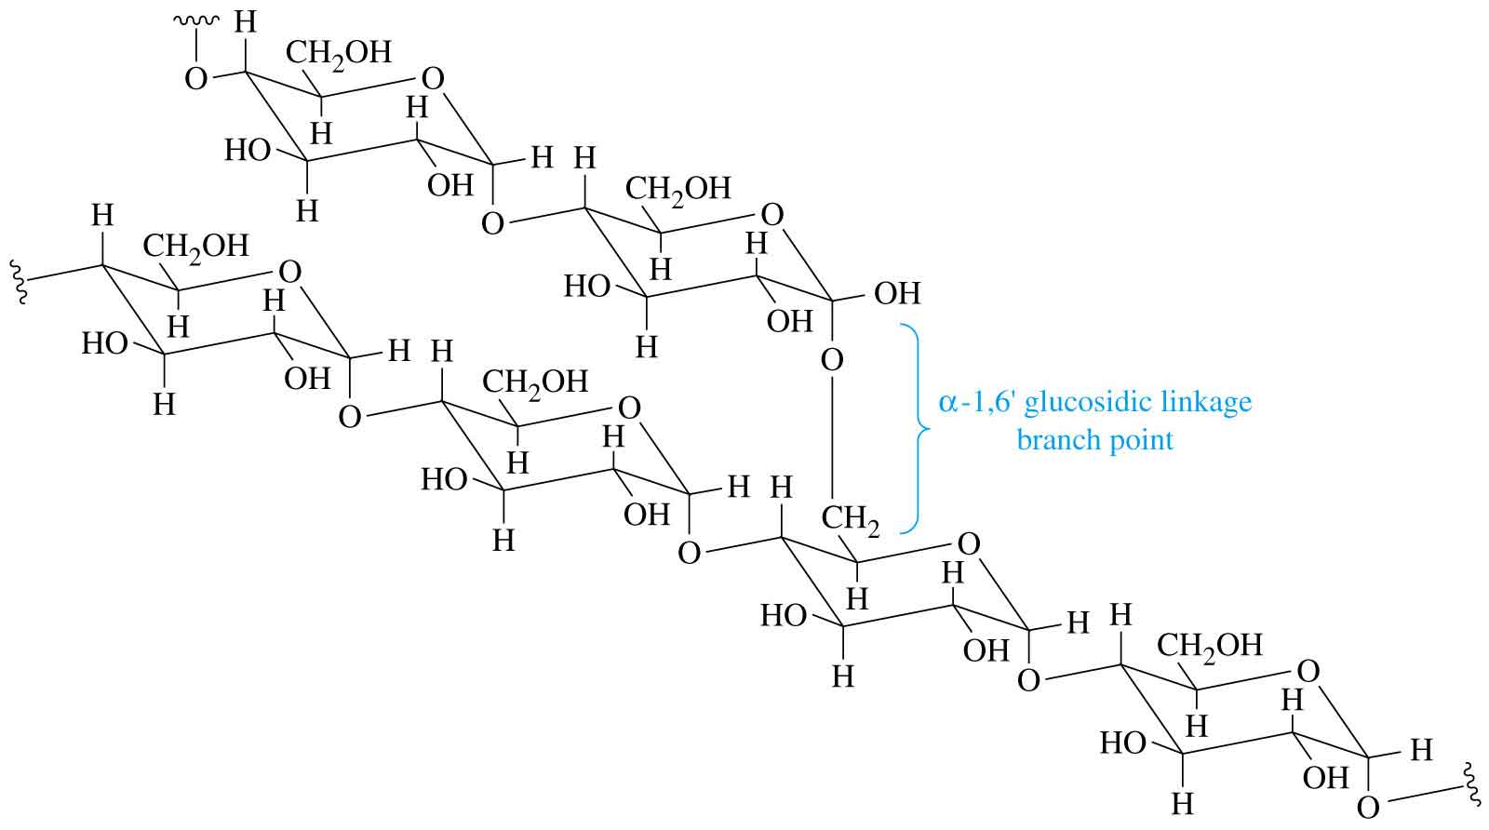

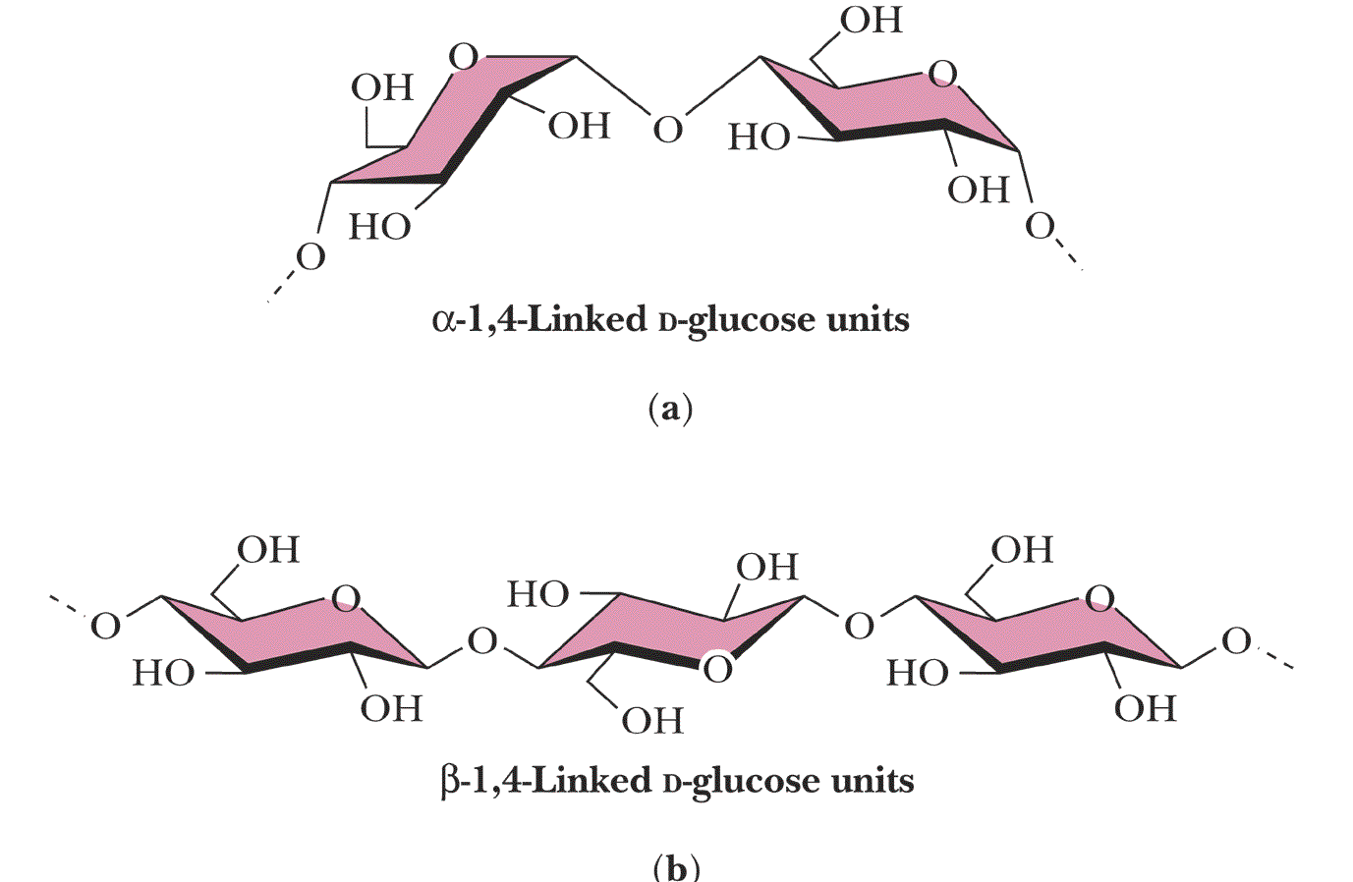

**Cellulose**

* Polymer of β-D-glucose attached by b(1,4) linkages
* Yields glucose upon complete hydrolysis
* Partial hydrolysis yields cellobiose
* Most abundant of all carbohydrates
  + - Cotton flax: 97-99% cellulose
    - Wood: ~ 50% cellulose
* Gives no color with iodine
* Held together with lignin in woody plant tissues

Linear structures of cellulose and chitin (2 most abundant polysaccharides)

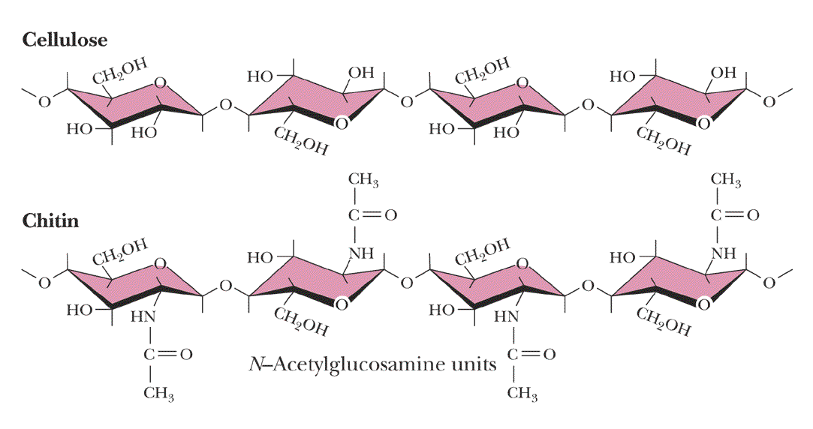

**Glycogen**

* also known as animal starch
* stored in muscle and liver
* present in cells as granules (high MW)
* contains both a(1,4) links and a(1,6) branches at every 8 to 12 glucose unit
* complete hydrolysis yields glucose
* glycogen and iodine gives a red-violet color
* hydrolyzed by both a and b-amylases and by glycogen phosphorylase

**Inulin**

* b-(1,2) linked fructofuranoses
* linear only; no branching
* lower molecular weight than starch
* colors yellow with iodine
* hydrolysis yields fructose
* sources include onions, garlic, dandelions and jerusalem artichokes
* used as diagnostic agent for the evaluation of glomerular filtration rate (renal function test)

**Chitin**

* Chitin is the second most abundant carbohydrate polymer
* Present in the cell wall of fungi and in the exoskeletons of crustaceans, insects and spiders
* Chitin is used commercially in coatings (extends the shelf life of fruits and meats)

**Dextrins**

* products of the reaction of glucose and the enzyme transglucosidase from *Leuconostoc mesenteroides*
* contains a (1,4), a (1,6) and a (1,3) linkages
* MW: 40,000; 70,000; 75,000
* used as plasma extenders (treatment of shock)
* also used as molecular sieves to separate proteins and other large molecules (gel filtration chromatography)
* components of dental plaques
* produced by the partial hydrolysis of starch along with maltose and glucose
* dextrins are often referred to as either amylodextrins, erythrodextrins or achrodextrins
* used as mucilages (glues)
* also used in infant formulas (prevent the curdling of milk in baby’s stomach)

**Pectins**

* pectins are heteropolysaccharides found in the pulp of fruits (citrus, apples)
* on hydrolysis pectins yield galacturonic acid, galactose, arabinose, methanol and acetic acid
* pectins are composed of galactans and arabans
* used as gelling agents (to make jellies)

Gums

* widely used in the food and pharmaceutical industry
* used as: suspending agents, gelling agents, thickening agents, emulsifiers, foam stabilizers, crystallization inhibitors, adhesives, binding agents
* agar, tragacanth, karaya, carrageenan, guar gum, gum arabic (acacia), furcellaran, sodium alginate, locust bean gum