Enzymes

- Are organic compounds that catalyses biological reactions that enable the system to store and release energy whenever it is needed.
- Are made up of highly specialized protein molecules and thus behave like proteins. They are mostly globular proteins consisting entirely of amino acid chains. Others are more complex, containing additional chemical components.
- they do not do the impossible - they only speed up reactions
- they are not consumed in a reaction
- they work for both the forward and the reverse reaction
- they are highly selective
- Like all catalysts, enzymes work by lowering the activation energy (ΔG‡) for a reaction, thus dramatically accelerating the rate of the reaction.
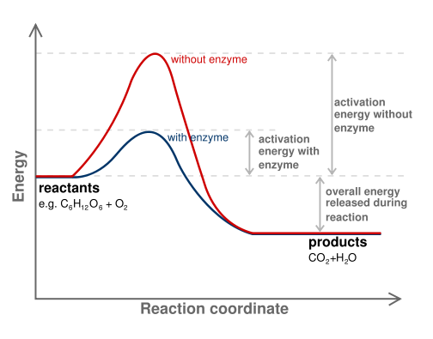
Examples:
- Catalase. It catalyzes the decomposition of hydrogen peroxide into water and oxygen.
2H₂O₂ -> 2H₂O + O₂

One molecule of catalase can break 40 millionmolecules of hydrogen peroxide each second.

- Carbonic anhydrase. It is found in red blood cells where it catalyzes the reaction
CO₂ + H₂O H₂CO₃

It enables red blood cells to transport carbon dioxide from the tissues to the lungs.
One molecule of carbonic anhydrase can process one million molecules of CO₂ each second.

- Undergo all reactions of proteins including denaturation. Slight alterations in pH, temperature, or other protein denaturants affect enzyme activity dramatically. They are so sensitive that they respond automatically to changes in the cell.
- catalyze about 4,000 biochemical reactions.

Importance of Enzymes
- They are used to prepare food.
- Enzymes act as biological catalyst.

General Classes
- Simple Enzymes
These are enzymes that contain amino acids only. The activity of the enzyme results from the proper three-dimensional arrangement of amino acids contained within the protein.

Ex. Amylase is an enzyme. It is found in saliva and pancreatic juice. It can break down starch into maltose.

- Conjugated Enzymes - These are enzymes that contain a non-protein group in addition to the protein portion. In conjugated protein, only the combination of the protein and the non-protein portion will make it function.
- The protein part of the conjugated enzyme without the non-protein part required for it to function is called apoenzyme. It is an inactive enzyme. An active conjugated enzyme that contains the protein and the non-protein part is called holoenzyme. The non-protein part of these enzymes is called cofactors. If the cofactor is an organic molecule, they are called coenzymes.
Cofactor
- non-protein enzyme helper
- aid in enzyme catalytic function
- may be bound tightly to the active site or may be loosely bound
- may be inorganic, such as a zinc or copper ion, or it may be an organic molecule
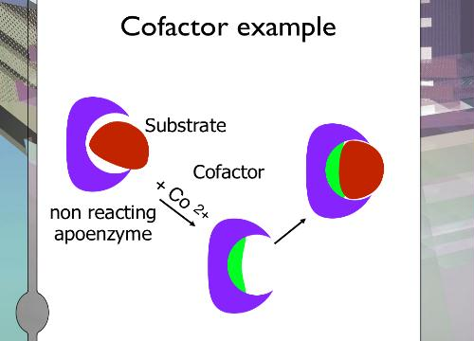

Coenzymes
- Coenzymes are simple organic compound that are endowed with specific structural features that allow them to help accelerate enzyme reactions. Many of the coenzymes are closely related to vitamins.
- Coenzymes are small molecules that transport chemical groups from one enzyme to another.

Some Common Coenzymes

Coenzyme
- are irreversibly changed during catalysis; they are either unmodified or regenerated.
Sometimes an enzyme requires a metal for its activity. These inorganic ions that function as cofactor are called activators.
Selected conjugated enzymes containing activators

General Characteristics of Enzymes
1.Oxidoreductases- these are enzymes that catalyze oxidation-reduction (redox) reaction in the cell.
1.1Dehydrogenases- enzymes that convert single to double bonds by removal of H2.
1.1.2 Oxidase- catalyze reaction that uses oxygen as an oxidizing agent.
1.1.3Peroxidase- catalyze reaction that use peroxide as an oxidizing agent.
1.4 Hydroxylases- enzymes that introduce hydroxyl groups.
1.5 Oxygenases- catalyze reaction that introduces molecular oxygen place of a double bond.

2. Transferases- these are enzymes involve in the transfer of functional groups from one substrate to another.
2.1 Kinase- involve in the transfer of phosphate group from ATP
2.2 Aminotransferase- involve in the transfer of amino group
2.3 Transketolase- transfer to a ketone group
2.4 Transaldolase- transfer of aldehyde group

3. Hydrolase- these are enzymes involve in the hydrolysis reaction, that is, cleavage or breaking of bonds by its reaction with water.
3.1 Proteinase- enzymes that act on proteins (hydrolysis of peptide bond)
3.2 Amylases- enzymes that act on starch with the break down of glycosidic bond.
3.3 Lipase- enzymes that act on lipids breaking the ester bond.
3.4 Ribonucleases-enzymes that act on nucleic acids

4. Lyases- these are enzymes that catalyse the breakdown of bonds without the addition of reaction but by elimination reaction to form a double bonds or rings.
4.1 Decarboxylase- involve in the removal of carbon dioxide
4.2 Deaminases- involve in the removal of amino group

5. Isomerase- enzyme that catlyzes the conversion from one isomer to another.
5.1 Racemase- enzymes that catalyses the conversion of and L-isomer to a D-isomer and vice versa.
e.g. L-glutamic acid D-glutamic acid
5.2 Epimerases- enzyme involved in the conversion of one structure into its epimer.
e.g. UDP-galactose UDP-glucose
5.3 Mutases - enzyme involve in the transfer of one part of the molecule to another part.

6. Ligases-these are enzymes involve in the synthetic reaction joining two molecules together. Usually, the reaction requires the input energy from ATP.
ATP ADP
e.g. 2 nucleotide dinucleotide

Levels of Specificity
Enzymes exhibit levels of selectivity of specificity for substrates. The active site of the enzyme determines selectivity since it regulates what substances can enter. Usually, an enzyme accommodates only one substrate or a few closely related substrates.

1. Absolute specificity
An enzyme accepts one of a particular substrate and no other. Example is urease that acts only on urea. The absolute specificity is the most limited case of enzyme specificity.

2. Group specificity
These are enzymes that act on a set of closely related molecules, all of which contain the same functional group. Example is phosphatase that hydrolyze linkages in a variety of compounds possessing the phosphate functional group.

3. Linkage specificity
These are enzymes that attack certain bonds within molecules. Esterases are example of this group that catalyze the hydrolysis of any compound that contain the ester bond.

4. Stereochemical specificity
These refer to enzymes that will accept substrates of only a particular stereochemical configuration. L-amino oxidase for example only catalyses reaction involving amino acids that is in the L-configuration.

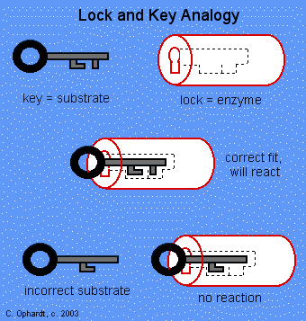
Lock and Key Theory
- Enzymes are very specific, and it was suggested by Emil Fischer in 1894 that this was because both the enzyme and the substrate possess specific complementary geometric shapes that fit exactly into one another

Induced-Fit Theory
- Proposed by Daniel Koshland
- The induced-fit model allows for small changes in the shape of geometry of the active site of an enzyme to accommodate a substrate. The induced fit is a result of the enzymes flexibility; it adapts to accept the incoming substrate. A good example of enzyme that behaves this way is the hexokinase.
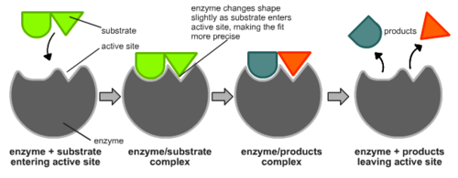
Factors Affecting Enzyme Activity
Enzyme Activity- is a measure of a rate at which an enzyme converts substrate to product.
- Temperature
- pH
- Substrate Concentration
- Enzyme Concentration

Temperature
- As the temperature rises, reacting molecules have more and more kinetic energy. This increases the chances of a successful collision and so the rate increases. There is a certain temperature at which an enzyme's catalytic activity is at its greatest.
- This optimal temperature is usually around human body temperature (37.5 ºC) for the enzymes in human cells.
- When the temperature increase beyond a certain point, the increased energy begins to cause disruptions in the tertiary structure of the enzyme. This results to denaturation and the loss of this active site impedes catalytic action, thus enzyme activity quickly decreases beyond the optimum temperature.

pH
- Each enzyme works within quite a small pH range. There is a pH at which its activity is greatest (the optimal pH).
- Most enzyme exhibit maximum activity at a certain pH.
- Not all enzymes posses the same pH optimums.
- It often varies between different tissues and even among compartments within individual cells.
Example: pepsin, a protein-digesting enzyme of the stomach functions best at a lower pH, but another protein digesting enzyme of the small intestine carboxypeptidase A, functions best at neutral pH.
- Extremely high or low pH values generally result in complete loss of activity for most enzymes. pH is also a factor in the stability of enzymes. As with activity, for each enzyme there is also a region of pH optimal stability.

pH for Optimum Activity

Substrate Concentration
- If we hold the concentration of the enzyme constant and increase the substrate concentration, enzyme activity increases to a certain substrate concentration and thereafter remains constant.
- As the substrate concentration increases, eventually, the capacity of the enzymes to keep up with the expected reaction rate is exceeded. When each enzyme is working at full capacity, the incoming substrate molecules must wait their turn at an active site. At this point, the enzyme is said to be under saturating conditions.

Enzyme Concentration
- Enzyme activity increases with enzyme concentration.

Enzyme Inhibitors
- Enzyme inhibitors are molecules that bind to enzymes and decrease their activity.
- The binding of an inhibitor can stop a substrate from entering the enzyme's active site and/or hinder the enzyme from catalyzing its reaction. Inhibitor binding is either reversible or irreversible.

Reversible Inhibition
- bind non-covalently and different types of inhibition are produced depending on whether these inhibitors bind the enzyme, the enzyme-substrate complex, or both.
- Competitive Inhibition
Are enzyme inhibitors that complete with normal substrates for binding to the active site of the enzyme.
In this case, the inhibiting compound so closely resembles the substrate for the enzyme that it accepts the molecule to the substrate binding site. However, once bound, the inhibitor cannot be acted on and thus prevent the enzyme from catalysing the intended reaction.
- Noncompetitive Inhibition
Slow enzyme activity by binding to a site on an enzyme other than the active site. It usually alters the overall tertiary structure of enzyme. Changing the active site lowers the affinity of the enzyme for the substrate, and thus affects the enzymes overall function. Lowering the concentration of the inhibitor free up many enzymes, which then return to normal activity.

Irreversible Inhibition
- Involves a covalent bonding of a molecule to the enzyme, which truly incapacitates it.
- occurs when substances combine covalently with enzymes so as to inactivate them irreversibly. Almost all irreversible enzyme inhibitors are toxic substances, either natural or synthetic.
- Almost all irreversible enzyme inhibitors are toxic substances, either natural or synthetic.

