Hormones
Hormones are chemical messengers produced by the endocrine glands in the human body. Hormones produced by these glands are secreted directly into the bloodstream. Some of the most important hormones in the human body are steroids. Cholesterol is not a steroid hormone, but many steroid hormones are made from it.
The Endocrine System
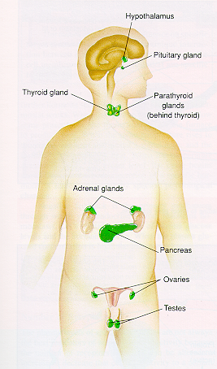
Functions of the Endocrine System
- Controls the processes involved in movement and physiological equilibrium
- Includes all tissues or glands that secrete hormones into the blood
- Secretion of most hormones is regulated by a negative feedback system
- The number of receptors for a specific hormone can be altered to meet the body’s demand
Types of Hormones
- Hormones are typically grouped into three classes:
  - Steroids
  - Amines
  - Peptides.

Steroid hormones
- Lipid and phospholipid-derived hormones derive from lipids such as linoleic acid and arachidonic acid and phospholipids. The main classes are the steroid hormones that derive from cholesterol and the eicosanoids. Examples of steroid hormones are testosterone and cortisol.
- Sterol hormones such as calcitriol are a homologous system. The adrenal cortex and the gonads are primary sources of steroid hormones. Examples of eicosanoids are the widely studied prostaglandins.
- Nearly all the steroid hormones are lipids synthesized from cholesterol; they are responsible for the development of many male and female sex characteristics.
  - Lipid soluble
    - Diffuse through cell membranes
    - Endocrine organs
    - Adrenal cortex
    - Ovaries
    - Testes
    - placenta

Amine Hormones
- Amine hormones are (all) derived from the amino acid tyrosine and tryptophan secreted by the thyroid.
- Examples are catecholamines and thyroxine.
- Nonsteroid Hormones:
- Not lipid soluble
- Received by receptors external to the cell membrane
- Endocrine organs
  - Thyroid gland
  - Parathyroid gland
  - Adrenal medulla
  - Pituitary gland
  - pancreas

Peptide hormones
- Peptide hormones consist of chains of amino acids. Examples of small peptide hormones are TRH and vasopressin.
- Peptides composed of scores or hundreds of amino acids are referred to as proteins. Examples of protein hormones include insulin and growth hormone.
- More complex protein hormones bear carbohydrate side chains and are called glycoprotein hormones. Luteinizing hormone, follicle-stimulating hormone and thyroid-stimulating hormone are glycoprotein hormones.
- Most hormones are peptides, thus each with only a short chain of amino acids; they are synthesized largely as proteins first.

Hormone Actions
- Steroid Hormones
  - Pass through the cell membrane
  - Binds to specific receptors
  - Then enters the nucleus to bind with the cells DNA which then activates certain genes (Direct gene activation).
  - mRNA is synthesized in the nucleus and enters the cytoplasm and promotes protein synthesis for:
    - Enzymes as catalysts
    - Tissue growth and repair
    - Regulate enzyme function
- Nonsteroid Hormones
  - React with specific receptors outside the cell
  - This triggers an enzyme reaction with lead to the formation of a second messenger (cAMP).
  - cAMP can produce specific intracellular functions:
    - Activates cell enzymes
    - Change in membrane permeability
    - Promote protein synthesis
    - Change in cell metabolism
    - Stimulation of cell secretions

Negative Feedback
- Negative feedback is the primary mechanism through which your endocrine system maintains homeostasis
- Secretion of a specific hormone s turned on or off by specific physiological changes (similar to a thermostat)
- EXAMPLE: plasma glucose levels and insulin response

Number of Receptors
- Down-regulation: is the decrease of hormone receptors which decreases the sensitivity to that hormone
- Up-regulation: is the increase in the number of receptors which causes the cell to be more sensitive to a particular hormone
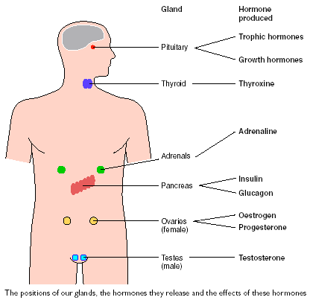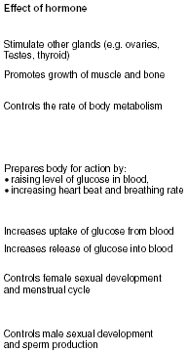

The Endocrine Glands and Their Hormones
- Pituitary Gland
  - A marble-sized gland at the base of the brain
  - Controlled by the hypothalamus or other neural mechanisms and therefore the middle man.
    - Posterior Lobe
      - Antidiuretic hormone: responsible for fluid retention
      - Oxytocin: contraction of the uterus
  - Exercise appears to be a strong stimulant to the hypothalamus for the release of all anterior pituitary hormones
    - Anterior Lobe
      - Adrenocorticotropin
    - Growth hormone *
      - Thyropin
      - Follicle-stimulating hormone
      - Luteinizing hormone *
      - Prolactin
- Thyroid Gland
  - Located along the midline of the neck
  - Secretes two nonsteroid hormones
    - Triiodothyronine (T3)
    - Thyroxine (T4)
  - Regulates metabolism
    - increases protein synthesis
    - promotes glycolysis, gluconeogenesis, glucose uptake
    - Calcitonin: calcium metabolism
- Parathyroid Glands
  - Secretes parathyroid hormone
    - regulates plasma calcium (osteoclast activity)
    - regulates phosphate levels

- Adrenal Medulla
  - Situated directly atop each kidney and stimulated by the sympathetic nervous system
  - Secretes the catecholamines
    - Epinephrine: elicits a fight or flight response
      - Increase H.R. and B.P.
      - Increase respiration
      - Increase metabolic rate
      - Increase glycogenolysis
      - Vasodilation
    - Norepinephrine
      - House keeping system

- Adrenal Cortex
- Secretes over 30 different steroid hormones (corticosteroids)
  - Mineralocorticoids
    - Aldosterone: maintains electrolyte balance
  - Glucocorticoids
    - Cortisol:
      - Stimulates gluconeogenisis
      - Mobilization of free fatty acids
      - Glucose sparing
      - Anti-inflammatory agent
  - Gonadocorticoids
    - testosterone, estrogen, progesterone

- Pancreas:
  - Located slightly behind the stomach
- Insulin: reduces blood glucose
  - Facilitates glucose transport into the cells
  - Promotes glycogenesis
  - Inhibits gluconeogensis
- Glucagon: increases blood glucose

- Gonads
  - testes (testosterone) = sex characteristics
    - muscle development and maturity
  - ovaries (estrogen) = sex characteristics
    - maturity and coordination

- Kidneys (erythropoietin)
  - regulates red blood cell production

Regulation of Glucose Metabolism During Exercise
- Glucagon secretion increases during exercise to promote liver glycogen breakdown (glycogenolysis)
- Epinephrine and Norepinephrine further increase glycogenolysis
- Cortisol levels also increase during exercise for protein catabolism for later gluconeogenesis.
- Growth Hormone mobilizes free fatty acids
- Thyroxine promotes glucose catabolism
- As intensity of exercise increases, so does the rate of catecholamine release for glycogenolysis
- During endurance events the rate of glucose release very closely matches the muscles need. When glucose levels become depleted, glucagon and cortisol levels rise significantly to enhance gluconeogenesis.
- Glucose must not only be delivered to the cells, it must also be taken up by them. That job relies on insulin.
- Exercise may enhance insulin’s binding to receptors on the muscle fiber.
- Up-regulation (receptors) occurs with insulin after 4 weeks of exercise to increase its sensitivity (diabetic importance).

Regulation of Fat Metabolism During Exercise
- When low plasma glucose levels occur, the catecholamines are released to accelerate lypolysis.
- Triglycerides are reduced to free fatty acids by lipase which is activated by:
  - Cortisol
  - Epinephrine
  - Norepinephrine
  - Growth Hormone

Hormonal Effects on Fluid and Electrolyte Balance
- Reduced plasma volume leads to release of aldosterone which increases Na+ and H₂O reabsorption by the kidneys and renal tubes.
- Antidiuretic Hormone (ADH) is released from the posterior pituitary when dehydration is sensed by osmoreceptors, and water is then reabsorbed by the kidneys.

Steroid Hormones
- produced and secreted at two major places in the human body
  - the adrenal glands
  - the gonads (the testes in males and the ovaries in females)

Glucocorticoids
Glucocorticoids regulate the body’s use of glucose – how much is burned as fuel to provide energy and how much is stored as glycogen for future energy needs. Glucocorticoids tend to prevent the uptake of glucose by tissues and therefore promote its storage as glycogen. Other nonsteroid hormones, especially insulin, promote the uptake of glucose by tissues. Together, the glucocorticoids and insulin maintain the body’s delicate balance between too much and too little glucose. Glucocorticoids also affect body protein and fat utilization in a similar way.

Mineralocorticoids
Mineralocorticoids help retain sodium chloride and maintain fluid balance in the body. All corticoids affect salt and water balance to some extent but aldosterone is by far the most important mineralocorticoid. Aldosterone’s sodium chloride - retaining activity is about 1000 times the activity of cortisol, for example. Aldosterone is the principal hormone in maintaining life in an animal whose adrenals have been removed.

Male sex hormones
Testosterone is the principal sex hormone in males and is produced in testes (testicles).
The testes perform two functions; they produce sperm, and they produce testosterone. At puberty, testosterone promotes the maturation and growth of the male sex organs. It also aids in the development of male secondary sex characteristics such as deep voices and beards, and it contributes to the greater muscular development and bone growth of males compared with females.

Women also produce testosterone. Masculinization does not occur in normal women, however, because chemical reactions in a woman’s body rapidly convert testosterone into female hormones.

The adrenal cortex also produces sex hormones - androgens in males and estrogens in females. Beginning at puberty, androgens and estrogen produce the secondary sex characteristics considered masculine or feminine: deep voices and beards in males, higher voices, breast development, and lack of facial hair in females.

