***LIPIDS***

* Definition: water insoluble compounds
  + - Most lipids are fatty acids or ester of fatty acid
    - They are soluble in non-polar solvents such as petroleum ether, benzene, chloroform
* Functions
  + - Energy storage
    - Structure of cell membranes
    - Thermal blanket and cushion
    - Precursors of hormones (steroids and prostaglandins)
* Types:
  + Fatty acids
  + Neutral fats and oils
  + Waxes
  + Phospholipid
  + Sterols

**Fatty acids**

* Common fatty acids

n = 4 butyric acid (butanoic acid)

n = 6 caproic acid (hexanoic acid)

n = 8 caprylic acid (octanoic acid)

n = 10 capric acid (decanoic acid)

n = 12: lauric acid (n-dodecanoic acid; C12:0)

n = 14: myristic acid (n-tetradecanoic acid; C14:0)

n = 16: palmitic acid (n-hexadecanoic acid; C16:0)

n = 18; stearic acid (n-octadecanoic acid; C18:0)

n = 20; arachidic (eicosanoic acid; C20:0)

n= 22; behenic acid

n = 24; lignoceric acid

n = 26; cerotic acid

**Saturated Fatty Acids**



**Unsaturated fatty acids**



* Monoenoic acid (monounsaturated)
* Double bond is always *cis* in natural fatty acids. This lowers the melting point due to “kink” in the chain



3, 6 - Octadienoic Acid

8:2 (𝚫3,6)

* Polyenoic acid (polyunsaturated)



Properties of fats and oils

* fats are solids or semi solids
* oils are liquids
* melting points and boiling points are not usually sharp (most fats/oils are mixtures)
* when shaken with water, oils tend to emulsify
* pure fats and oils are colorless and odorless (color and odor is always a result of contaminants) – i.e. butter (bacteria give flavor, carotene gives color)

Examples of oils

* Olive oil – from *Oleo europa* (olive tree)
* Corn oil – from *Zea mays*
* Peanut oil – from *Arachis hypogaea*
* Cottonseed oil – from *Gossypium*
* Sesame oil – from *Sesamum indicum*
* Linseed oil – from *Linum usitatissimum*
* Sunflower seed oil – from *Helianthus annuus*
* Rapeseed oil – from *Brassica rapa*
* Coconut oil – from *Cocos nucifera*

**Non-drying, semi-drying and drying oils**

* based on the ease of autoxidation and polymerization of oils (important in paints and varnishes)
* the more unsaturation in the oil, the more likely the “drying” process
  + Non-drying oils:
    - Castor, olive, peanut, rapeseed oils
  + Semi-drying oils
    - Corn, sesame, cottonseed oils
  + Drying oils
    - Soybean, sunflower, hemp, linseed, tung, oiticica oils

**Soaps**

* Process of formation is known as saponification
  + Types of soaps:
    - Sodium soap – ordinary hard soap
    - Potassium soap – soft soap (shaving soaps are potassium soaps of coconut and palm oils)
    - Castile soap – sodium soap of olive oil
    - Green soap – mixture of sodium and potassium linseed oil
    - Transparent soap – contains sucrose
    - Floating soap – contains air
    - Calcium and magnesium soaps are very poorly water soluble (hard water contains calcium and magnesium salts –these insolubilize soaps)

**Hydrogenated fats**

* hydrogenation leads to either saturated fats and/or trans fatty acids
* the purpose of hydrogenation is to make the oil/fat more stable to oxygen and temperature variation (increase shelf life)
* example of hydrogenated fats: Crisco, margarine

**Neutral lipids**

* Glycerides (fats and oils) ;glycerides



* + Glycerol
  + Ester of glycerol - monoglycerides, diglycerides and triglycerides
  + Waxes – simple esters of long chain alcohols

**Glycerides**

Function: storage of energy in compact form and cushioning



**Waxes**

* simple esters of fatty acids (usually saturated with long chain monohydric alcohols)



* Fatty acids + Long chain alcohol
* ***Beeswax* – also includes some free alcohol and fatty acids**
* ***Spermaceti* – contains cetyl palmitate (from whale oil) –useful for**
* **Pharmaceuticals (creams/ointments; tableting and granulation)**
* ***Carnauba wax* – from a palm tree from brazil – a hard wax used on cars and boats**

Important in fruits:

1. Natural protective layer in fruits, vegetables, etc.
2. Added in some cases for appearance and protection.

**Phospholipids**

* the major components of cell membranes
  + phosphoglycerides -



Phospholipids are generally composed of FAs, a nitrogenous base, phosphoric acid and either glycerol, inositol or sphingosine

**Glycolipids**



There are different types of glycolipids: cerebrosides, gangliosides, lactosylceramides

* Cerebrosides
  + - One sugar molecule
      * Galactocerebroside – in neuronal membranes
      * Glucocerebrosides – elsewhere in the body
* Sulfatides or sulfogalactocerebrosides
  + - A sulfuric acid ester of galactocerebroside
* Globosides: ceramide oligosaccharides
  + - Lactosylceramide
      * 2 sugars ( eg. lactose)
* Gangliosides
  + - Have a more complex oligosaccharide attached
    - Biological functions: cell-cell recognition; receptors for hormones

**Cardiolipids**



A polyglycerol phospholipid; makes up 15% of total lipid-phosphorus content of the myocardium – associated with the cell membrane

Cardiolipids are antigenic and as such are used in serologic test for syphilis (Wasserman test)

**Sulfolipids**

* also called sulfatides or cerebroside sulfates
* contained in brain lipids
* sulfate esters of cerebrosides
* present in low levels in liver, lung, kidney, spleen, skeletal muscle and heart
* function is not established

**Lipid storage diseases**

* also known as sphingolipidoses
* genetically acquired
* due to the deficiency or absence of a catabolic enzyme
  + - Tay Sachs disease - a fatal disease which is due to the deficiency of hexosaminidase A activity
    - accumulation of ganglioside GM2 in the brain of infants
    - mental retardation, blindness, inability to swallow
    - a “cherry red “ spot develops on the macula (back of the the eyes)
    - Tay-Sachs children usually die by age 5 and often sooner
    - Gaucher’s disease - Caused by a deficiency of lysosomal glucocerebrosidase
    - Increase content of glucocerebroside in the spleen and liver
    - Erosion of long bones and pelvis
    - Enzyme replacement therapy is available for the Type I disease (Imiglucerase or Cerezyme)
    - Niemann-Pick disease - principal storage substance: sphingomyelin which accumulates in reticuloendothelial cells
    - enzyme deficiency: sphingomyelinase
    - liver and spleen enlargement, mental retardation
    - Fabry’s disease - Accumulation of ceramide trihexoside in kidneys of patients who are deficient in lysosomal a-galactosidase A sometimes referred to as ceramide trihexosidase
    - Skin rash, kidney failure, pains in the lower extremities
    - Now treated with enzyme replacement therapy: agalsidase beta (Fabrazyme)
* Krabbe’s disease:
  + - Also known as globoid leukodystrophy
    - Increased amount of galactocerebroside in the white matter of the brain
    - Caused by a deficiency in the lysosomal enzyme galactocerebrosidase
* Metachromatic leukodystrophy
  + - accumulation of sulfogalactocerebroside (sulfatide) in the central nervous system of patient having a deficiency of a specific sulfatase
    - mental retardation, nerves stain yellowish-brown with cresyl violet dye (metachromasia)
* Generalized gangliosidosis
  + - accumulation of ganglioside GM1
    - deficiency of GM1 ganglioside: b-galactosidase
    - mental retardation, liver enlargement, skeletal involvement

**STEROIDS**



**Cholesterol** sources, biosynthesis and degradation

* diet: only found in animal fat
* biosynthesis: primarily synthesized in the liver from acetyl-coA; biosynthesis is inhibited by LDL uptake
* degradation: only occurs in the liver

Functions of cholesterol

* serves as a component of membranes of cells (increases or moderates membrane fluidity)
* precursor to steroid hormones and bile acids
* storage and transport –cholesterol esters

**Bile acids/Salts**

* Detergentlike compounds that aid in the emulsification and absorption of lipids in the intestine.
  + Cholic acid
  + Deoxycholic acid
  + Chenodeoxycholic acid
  + Lithocholic acid

**Steroid Hormones**

* Estrogens – synthesized in the ovaries and adrenal cortex and are responsible for the development of secondary sex characteristics at the onset of puberty and for the regulation of menstrual cycle
* Androgens – synthesized in the testes and adrenal cortex to promote secondary male characteristics and muscle growth
* Progestins – synthesized in the ovaries and the placenta and prepare the lining of the uterus for implantation of the fertilized ovum
* Adrenocortical hormones – produced by adrenal glands
  + Mineralcorticoids – control Na and K balance in the cell
  + Glucocorticoids – control glucose metabolism and counteract inflammation

**Prostaglandins and other eicosanoids**

* local hormones, unstable, key mediators of inflammation
* derivatives of prostanoic acid



Functions of eicosanoids

* Prostaglandins – particularly PGE1 – block gastric production and thus are gastric protection agents
* Misoprostol (Cytotec) is a stable PGE1 analog that is used to prevent ulceration by long term NSAID treatment
* PGE1 also has vasodilator effects
  + Alprostadil (PGE1) – used to treat infants with congenital heart defects
  + Also used in impotence (Muse)
* PGF2a – causes constriction of the uterus
  + Carboprost; “Hebamate” (15-Me-PGF2a) – induces abortions
* PGE2 is applied locally to help induce labor at term

Functions of prostaglandins

* Raising body temperature
* Inhibiting the secretion of gastric juices
* Relaxing and contracting smooth muscle
* Directing water and electrolyte balance
* Intensifying pain
* Enhancing inflammation responses

**Leukotrienes**

Leukotrienes are derived from arachidonic acid



Leukotrienes are synthesized in neutrophils, monocytes, macrophages, mast cells and keratinocytes. Also in lung, spleen, brain and heart. A mixture of LTC4, LTD4 and LTE4 was previously known as the

*slow-reacting substance of anaphylaxis*

Biological activities of leukotrienes

1. LTB4 - potent chemoattractant , mediator of hyperalgesia and growth factor for keratinocytes

2. LTC4 - constricts lung smooth muscle and promotes capillary leakage

3. LTD4 - constricts smooth muscle; lung airway hyperactivity and vasoconstriction

4. LTE4 - 1000 x less potent than LTD4 (except in asthmatics)

**Lipoproteins**

* particles found in plasma that transport lipids including cholesterol
* lipoprotein classes
  + - chylomicrons: take lipids from small intestine through lymph cells
    - very low density lipoproteins (VLDL)
    - intermediate density lipoproteins (IDL)
    - low density lipoproteins (LDL)
    - high density lipoproteins (HDL)

|  |  |  |  |  |  |
| --- | --- | --- | --- | --- | --- |
| **Lipoprotein class** | **Density (g/mL)** | **Diameter (nm)** | **Protein % of dry wt** | **Phospho lipid %** | **Triacyl glycerol % of dry wt** |
| **HDL** | **1.063-1.21** | **5 – 15** | **33** | **29** | **8** |
| **LDL** | **1.019 – 1.063** | **18 – 28** | **25** | **21** | **4** |
| **IDL** | **1.006-1.019** | **25 - 50** | **18** | **22** | **31** |
| **VLDL** | **0.95 – 1.006** | **30 - 80** | **10** | **18** | **50** |
| **chylomicrons** | **< 0.95** | **100 - 500** | **1 - 2** | **7** | **84** |

**Composition and properties of human lipoproteins**

most proteins have densities of about 1.3 – 1.4 g/mL and lipid aggregates usually have densities of about 0.8 g/mL

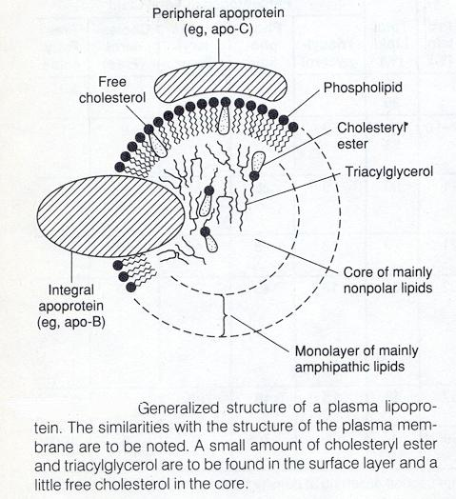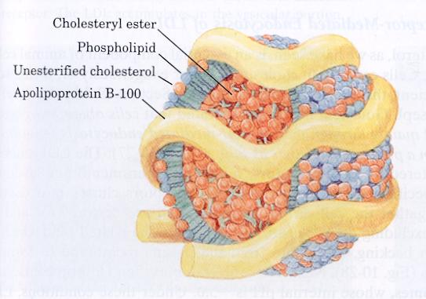

* spherical particles with a hydrophobic core (TG and esterified cholesterol)
* apolipoproteins on the surface
  + - large: apoB (b-48 and B-100) atherogenic
    - smaller: apoA-I, apoC-II, apoE
* classified on the basis of density and electrophoretic mobility (VLDL; LDL; IDL;HDL; Lp(a)

**Terpenes**

* simple lipids, but lack fatty acid component
* formed by the combination of 2 or more molecules of 2-methyl-1,3-butadiene (isoprene)
* monoterpene (C-10) – made up of 2 isoprene units
* sesquiterpene (C-15) – made up of 3 isoprene units
* diterpene (C-20) – made up of 4 isoprene units



* tetraterpenes (C-40) are not as common as mono, di, and triterpenes
  + include the carotenoids such as beta-carotene (precursor of vitamin A) and lycopene found in tomatoes
  + usually colorful compounds due to highly conjugated system
* polyisoprenoids or polyprenols consist of numerous isoprene adducts (8 – 22)
  + examples include dolichol phosphate, undecaprenyl alcohol (bactoprenol) and the side chains of vitamins K, vitamin E and coenzyme Q

**Vitamin A**

* Pigment essential to vision
* Acts in the body as anti oxidant
* Occur in plants as carotenoids
* Retinol – storage form in the body
* Retinoic acid – functions in embryonic development
* Deficiency leads to xeropthalmia, dry skin, dry mucus membranes, retarded develepoment and growth, sterility in male animals and night blindness

**Vitamin E**

* Collective name for a group of lipids called tocopherols
* Abundant in vegetable oils, hen’s egg and wheat germ
* Functions as anti oxidant

**Vitamin K**

* Lipid cofactor required for normal blood clotting
* Vitamin K1 – found in green plant leaves
* Vitamin K2 – formed by bacteria residing in the animal intestine
* Deficiency leads to slower blood clotting