Nucleic Acid

- nucleic acid is a complex, high-molecular-weight biochemical macromolecule composed of nucleotide chains that convey genetic information
- The most common nucleic acids are deoxyribonucleic acid (DNA) and ribonucleic acid (RNA). Nucleic acids are found in all living cells and viruses.

Chemical structure
- The term "nucleic acid" is the generic name of a family of biopolymers, named for their prevalence in cellular nuclei. The monomers from which nucleic acids are constructed are called nucleotides
- Each nucleotide consists of three components: a nitrogenous heterocyclic base, either a purine or a pyrimidine; a pentose sugar; and a phosphate group
- Different nucleic acid types differ in the structure of the sugar in their nucleotides; DNA contains 2-deoxyriboses while RNA contains ribose
- Likewise, the nitrogenous bases found in the two nucleic acids are different: adenine, cytosine, and guanine are in both RNA and DNA, while thymine only occurs in DNA and uracil only occurs in RNA
- Nucleic acids are usually either single-stranded or double-stranded, though structures with three or more strands can form. A double-stranded nucleic acid consists of two single-stranded nucleic acids hydrogen-bonded together
- RNA is usually single-stranded, but any given strand may fold back upon itself to form double-helical regions
- DNA is usually double-stranded, though some viruses have single-stranded DNA as their genome
- The sugars and phosphates in nucleic acids are connected to each other in an alternating chain, linked by shared oxygens, forming a phosphodiester functional group. In conventional nomenclature, the carbons to which the phosphate groups are attached are the 3' and the 5' carbons of the sugar. The bases extend from a glycosidic linkage to the 1' carbon of the pentose sugar ring.
- Hydrophobic interaction of nucleic acids is poorly understood. For example, nucleic acids are insoluble in ethanol, TCA, and diluted hydrochloric acid; but they are soluble in diluted NaOH.

Nucleobase
- Nucleobases are the parts of RNA and DNA that may be involved in pairing. These include cytosine, guanine, adenine, thymine (DNA), uracil (RNA) and xanthine and hypoxanthine (mutated forms of guanine and adenine, respectively)
- These are abbreviated as C, G, A, T, U, X and HX respectively
- They are usually simply called bases in genetics
- Because A, G, C and T appear in the DNA, these molecules are called DNA-bases; A, G, C and U are called RNA-bases, respectively.
- Hypoxanthine and xanthine are created through mutagen presence, through deamination (replacement of the amine-group with a hydroxyl-group). Hypoxanthine is produced from adenine, xanthine from guanine and uracil from cytosine.
- Uracil replaces thymine in RNA. These two bases are identical except that uracil lacks the 5' methyl group. Adenine and guanine belong to the double-ringed class of molecules called purines (abbreviated as R). Cytosine, thymine, and uracil are all pyrimidines (abbreviated as Y).
- A base covalently bound to the 1' carbon of a ribose or deoxyribose is called a nucleoside, and a nucleoside with one or more phosphate groups attached at the 5' carbon is called a nucleotide

Purine and Pyrimidine bases
- The "skeleton" of adenine, guanine, hypoxanthine and xanthine is purine, hence the name purine-bases.
- The "skeleton" of cytosine, uracil and thymine is pyrimidine, hence pyrimidine-bases.

Purine Bases

Pyrimidine Bases

Nucleotide
- A nucleotide is a chemical compound that consists of 3 portions: a heterocyclic base, a sugar, and one or more phosphate groups. In the most common nucleotides the base is a derivative of purine or pyrimidine, and the sugar is the pentose (five-carbon sugar) deoxyribose or ribose. Nucleotides are the monomers of nucleic acids, with three or more bonding together in order to form a nucleic acid.
- Nucleotides are the structural units of RNA, DNA, and several cofactors - CoA, FAD, FMN, NAD, and NADP. In the cell they have important roles in energy production, metabolism, and signaling.
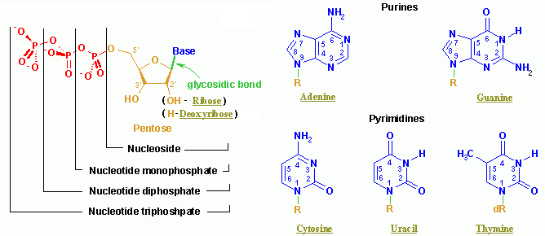

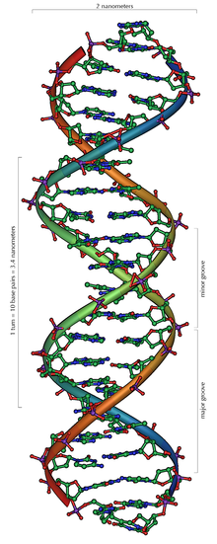
DNA
- Deoxyribonucleic acid, or DNA is a nucleic acid molecule that contains the genetic instructions used in the development and functioning of all living organisms.
- The main role of DNA is the long-term storage of information and it is often compared to a set of blueprints, since DNA contains the instructions needed to construct other components of cells, such as proteins and RNA molecules.
- The DNA segments that carry this genetic information are called genes, but other DNA sequences have structural purposes, or are involved in regulating the use of this genetic information.
- Chemically, DNA is a long polymer of simple units called nucleotides, which are held together by a backbone made of alternating sugars and phosphate groups. Attached to each sugar is one of four types of molecules called bases. It is the sequence of these four bases along the backbone that encodes information. This information is read using the genetic code, which specifies the sequence of the amino acids within proteins.
- The code is read by copying stretches of DNA into the related nucleic acid RNA, in a process called transcription. Most of these RNA molecules are used to synthesize proteins, but others are used directly in structures such as ribosomes and spliceosomes.
- Within cells, DNA is organized into structures called chromosomes and the set of chromosomes within a cell make up a genome. These chromosomes are duplicated before cells divide, in a process called DNA replication.
- Eukaryotic organisms such as animals, plants, and fungi store their DNA inside the cell nucleus, while in prokaryotes such as bacteria it is found in the cell's cytoplasm. Within the chromosomes, chromatin proteins such as histones compact and organize DNA, which helps control its interactions with other proteins and thereby control which genes are transcribed.

Physical and chemical properties
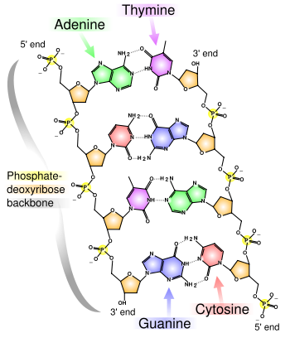
- DNA is a long polymer made from repeating units called nucleotides. DNA polymers can be enormous molecules containing millions of nucleotides. For instance, the largest human chromosome, chromosome number 1, is 220 million base pairs long.
- In living organisms, DNA does not usually exist as a single molecule, but instead as a tightly-associated pair of molecules. These two long strands entwine like vines, in the shape of a double helix. The nucleotide repeats contain both the segment of the backbone of the molecule, which holds the chain together, and a base, which interacts with the other DNA strand in the helix.
- In general, a base linked to a sugar is called a nucleoside and a base linked to a sugar and one or more phosphate groups is called a nucleotide. If multiple nucleotides are linked together, as in DNA, this polymer is referred to as a polynucleotide.
- The backbone of the DNA strand is made from alternating phosphate and sugar residues. The sugar in DNA is 2-deoxyribose, which is a pentose (five carbon) sugar. The sugars are joined together by phosphate groups that form phosphodiester bonds between the third and fifth carbon atoms of adjacent sugar rings.
- The asymmetric ends of a strand of DNA bases are referred to as the 5′ (five prime) and 3′ (three prime) ends. One of the major differences between DNA and RNA is the sugar, with 2-deoxyribose being replaced by the alternative pentose sugar ribose in RNA
- The DNA double helix is stabilized by hydrogen bonds between the bases attached to the two strands. The four bases found in DNA are adenine (abbreviated A), cytosine (C), guanine (G) and thymine (T). These four bases are shown below and are attached to the sugar/phosphate to form the complete nucleotide, as shown for adenosine monophosphate.

Base pairing
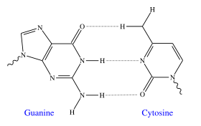
- Each type of base on one strand forms a bond with just one type of base on the other strand. This is called complementary base pairing. Here, purines form hydrogen bonds to pyrimidines, with A bonding only to T, and C bonding only to G. This arrangement of two nucleotides binding together across the double helix is called a base pair. In a double helix, the two strands are also held together via forces generated by the hydrophobic effect and pi stacking, which are not influenced by the sequence of the DNA
- As hydrogen bonds are not covalent, they can be broken and rejoined relatively easily. The two strands of DNA in a double helix can therefore be pulled apart like a zipper, either by a mechanical force or high temperature.As a result of this complementarity, all the information in the double-stranded sequence of a DNA helix is duplicated on each strand, which is vital in DNA replication. Indeed, this reversible and specific interaction between complementary base pairs is critical for all the functions of DNA in living organisms.

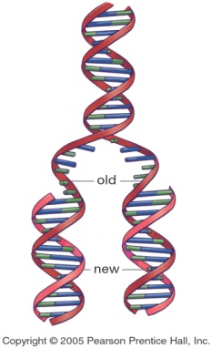
DNA replication
- Conservative – from one parental strand, two “daughter” double-stranded DNA’s are made. One contains two new strands and the other contains both of its original strand.
- Semi-conservative – from one parental double-stranded DNA, two daughter double stranded DNAs are made. Each daughter DNA contain one parental DNA strand and one newly made strand.
- Dispersive - from one parental double-stranded DNA, two daughter double stranded DNAs are made. Each strand in the daughter DNA contain portions of old and newly synthesized material.

RNA
- Ribonucleic acid (RNA) is a nucleic acid polymer consisting of nucleotide monomers, that acts as a messenger between DNA and ribosomes, and that is also responsible for making proteins out of amino acids. RNA polynucleotides contain ribose sugars and predominantly uracil unlike deoxyribonucleic acid (DNA), which contains deoxyribose and predominantly thymine.
- It is transcribed (synthesized) from DNA by enzymes called RNA polymerases and further processed by other enzymes. RNA serves as the template for translation of genes into proteins, transferring amino acids to the ribosome to form proteins, and also translating the transcript into proteins.

Chemical and Stereochemical structure
- RNA is a polymer with a ribose and phosphate backbone and four different bases: adenine, guanine, cytosine, and uracil. The first three are the same as those found in DNA, but in RNA thymine is replaced by uracil as the base complementary to adenine. This base is also a pyrimidine and is very similar to thymine.

Differences
 | RNA | DNA
Sugar backbone | ribose | deoxyribose
Base | A,G,C,U | A,T,C,G
Strand | Single | Double
Size | 75 to a few thousand nucleotides | Millions of nucleotides

Messenger RNA
- mRNA carries genetic information from DNA to ribosomes
- The sequence of bases in the mRNA strand is complementary tot hat of the DNA being transcribed. After transcription, the mRNA passes into the cytoplasm and then into the ribosomes, where it serves as a template for the sequential ordering of the amino acids during the biosynthesis of proteins.

Transfer RNA
- tRNA are relatively small molecule that act as a carrier of specific individual amino acids during the protein synthesis to the ribosomes
- They are the smallest RNA containing about 75-90 nucleotides

RNA
- rRNA combines with series of proteins to form complex structures, called ribosomes. This RNA constitutes about 65% of the mass of ribosomes

Primary transcript RNA
- Material from which mRNA is made

Transcription
- Process by which DNA directs the synthesis of RNA molecules that carry coded information for protein synthesis
  - A portion of DNA double helix unwinds, exposing some bases by the enzyme polymerase
  - Free ribonucleotides align along one of the exposed strands of DNA bases forming new base pairs
  - RNA polymerase links the aligned ribonucleotides
  - Transcription ends when the RNA polymerase encounters a sequence that is read as a stop signal
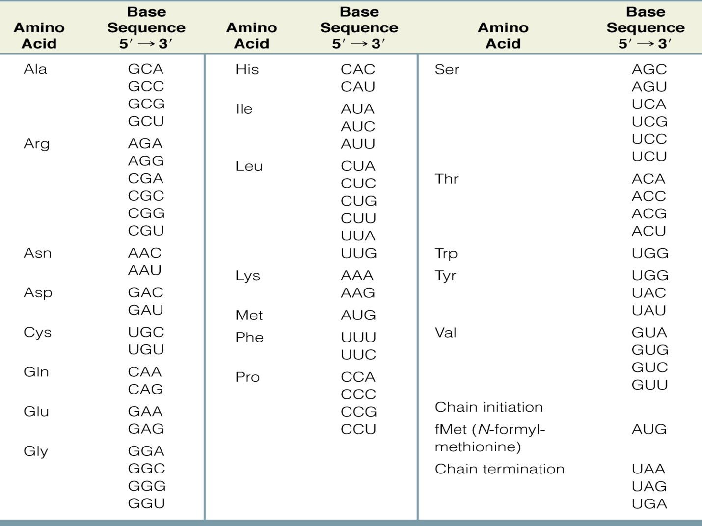

Translation
The process of reading the RNA and converting it into a sequence for a protein

Denaturation of DNA
- Extremes of pH
- Heat
- Decrease in dielectric constants of the medium by substances like alcohols and ketones
- Exposures to urea, amide and similar sources

Mutation
- Alteration in the base sequence in a DNA strand that results to a change in information stored. These changes alter the genetic information that is passed on during transcription. This results to a synthesis of proteins that is entirely different from what is prescribed by a normal DNA strand

Types of Mutation
- Transitions
  - One purine-pyrimidine base pair is replaced by another, so that a purine in one-chain is replaces by another purine and a pyrimidine in other chain by another pyrimidine
rep rep
C C* C* T
G G A A

- Transversions
  - A purine-pyrimidine pair is replaced by a pyrimidine –purine pair
rep rep
A A* A* T
T T T A

- Frame-shift
  - Insertion of an extra base pair

- Deletions
  - Results from loss of purine base because of high pH and temperature, actions of cross-linking agents or by alkylating ar deaminating agents, which cause the formation of bases that cannot pair

Induced mutation
- Chemical mutagens
  - Cigarette smoke
    - (polycylic aromatic hydrocarbos) – benzopyrene, benzofluoranthene, fluoranthene, pyrene, chrysene, benzoanthracene, anthracene, phenanathrene
  - N-nitrosamines
    - Dimethylnitrosamines, diethylnitrosamines, ethylmethylnitrosamines, N-nitrosonornicotine, di-N-propylnitrosamine
- PCAH – mispair or deletions
- N-nitrosamines – releases carbocations which are very active alkylating agents
- Alkoxy-free radicals, hydrazines and superoxide anion radicals interact with thymine leading to formation of a pyrimidinic sites that can result to mispair.
- Cd ions can alter the structure of DNA by reacting with the phosphate group

Mutagens in food systems
- Broiled foods (pyrolyzates, PCAH)
- Moldy foods (aflatoxin)
- Nitrite treated fish or meat (Nitrosamines)
- SO₂ treated fruits and vegetables <preservative> (transformed into bisulfite which is very reactive to cytosine)
- Ehtylene bromide treated fruits (alkylating agent)
- Mushroom (hydrazine)
- Beverages –
  - coffee (diacetyl hydrogen peroxide, caffeien and glyoxal)
    - Diacetyl is reactive with adenine
    - H₂O₂ give OH⁻ free radical which is reactive with thymine
    - Caffeine has chromosome breaking effect because it interferes with repair systems
  - Tea (flavonoids, quercetin & kaempferol, which can alter DNA structure
  - Alcoholic beverages (nitrosamines that are genotoxic)

Antimutagens
- Mechanisms
  - Direct trapping of mutagens
  - Inhibition of metabolism of mutagens
  - Inhibition of intercalation
  - Inhibition of alkylation
  - Inhibition of error-prone repair mechanisms
  - Stimulation of error-free repair mechanisms

