**Amino Acids: Building blocks of Protein**

**20 Amino acids**

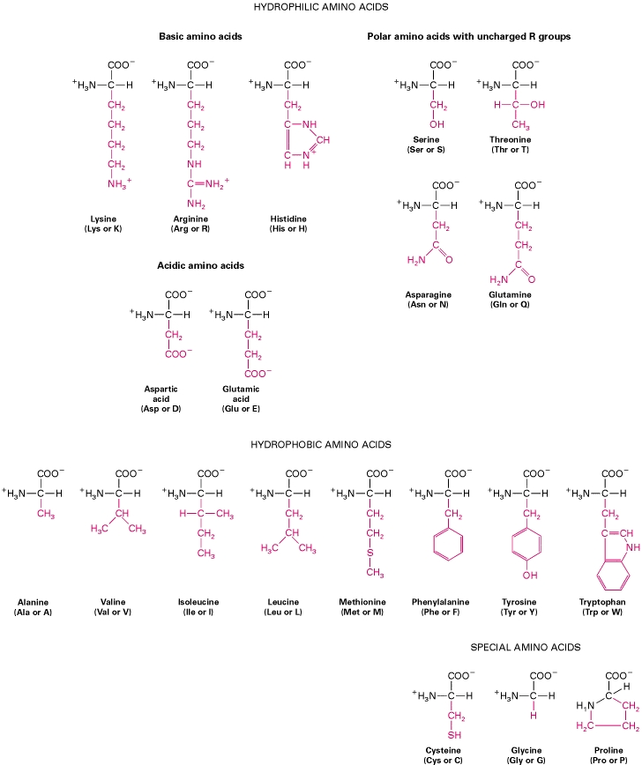

**Classification**

* Neutral amino acids
* Acidic amino acids
* Basic amino acids

**Neutral amino acids**

* Aliphatic amino acids
  + Monoaminomonocarboxylic acid
    - Glycine (gly), alanine (ala), valine (val), leucine (leu), isoleucine (ile)
  + Hydoxy amino acids
    - Serine (ser), threonine (thr)
* Heterocyclic amino acids
  + Tryptophan
  + histidine
* Imino acids
  + Proline
  + hydroxyproline
* Sulfur containing amino acids
  + Cysteine
  + Methionine

Effects of Proline upon protein structure

* a-helix stops w/ residue preceding Pro
* “Helix-breaking” amino acid
* Often found at turns

Cys has strong potential to form SS bridges

* + Aka Disulfides
* Additional covalent link leads to stability.

**Acidic amino acids**

* have two –COOH groups and one –NH2 group (monoaminodicarboxyliac acid)
  + Asparagine (asp)
  + Glutamic acid (glu)

**Basic amino acids**

* Consist of one –COOH group and two –NH2 group (diaminomonocarboxylic acid)
  + Arginine (arg)
  + Lysine (lys)
  + Hydroxylysine (hyl)

**Biological importance of amino acids**

* Some AA are converted into CHO’s (glucogenic amino acids)
* Specific AA gives specialized products
  + Tyr – thyroid hormones, epinephrine and norepinephrine and melanin
  + Trp – niacin
  + Gly, Arg, Met – creatine
  + Gly, Cys – bile salts
  + Glu, Cys, Gly – glutathione
  + Gly – heme and tripeptides
* Some AA such as gly and cys are used as detoxicants
* Met transfers methyl group to various substances by transmethylation
* Cys and Met are sources of sulfur

**Essential & Nonessential Amino Acids**

* Nine amino acids
  + Cannot be made (synthesized) by the body from other amino acids
  + Protein foods must be eaten daily that contain these amino acids
* 11 amino acids
  + Can be made from other parts
    - Nitrogen (other proteins)
    - Backbone (carbohydrates and fats)

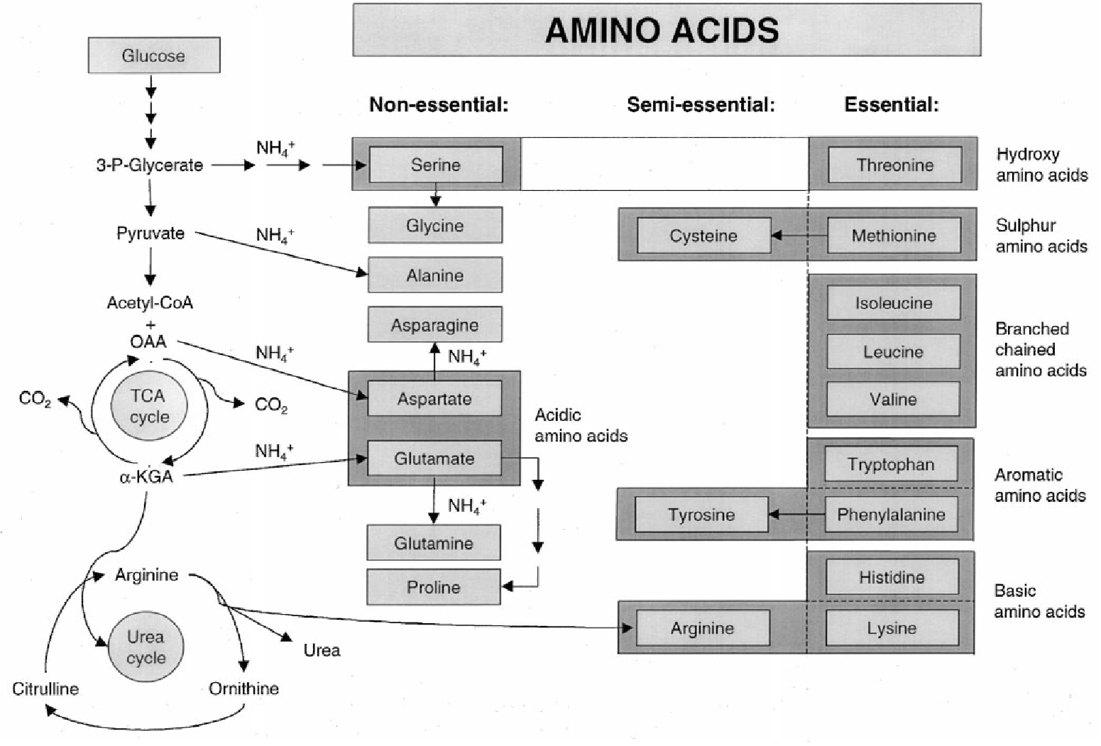

**Proteins**

* Derived fro the Greek word *Proteios* which means first. The name is given because they are the first among natural polymers essential for growth and maintenance of life
* Complex nitrogenous polymers present in all forms of living matter
* Contains carbon, hydrogen, oxygen and nitrogen. (may also contain sulfur and phosphorus)

**Peptides**

* Composed of amino acids linked together but they possess much smaller molecules than proteins and contain much fewer amino acids.
  + 2 AA – dipeptide
  + 3 AA – tripeptide
  + 4 -10 AA – oligopeptide
  + >10 AA - polypeptide

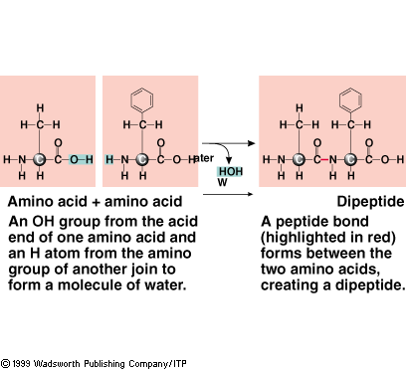

Proteins are linear polymers of amino acids

**Classification**

* Simple proteins
  + Proteins which on complete hydrolysis yields only amino acids.
  + Protamines
    - smallest molecule among protamines, they are basic, not coagulated by heat but soluble in water.
    - rich in arg but do not contain cys, tyr, trp
  + Histones
    - rich in arg and his, they are basic proteins
    - Soluble in water, dilute acids and salt solutions but insoluble in NH4OH, they are are not coagulated by heat
  + Albumins
    - Coagulated by heat and dissolve in acids, alkali and water
    - Generally deficient in gly
  + Globulins
    - Insoluble in acids, alkali and water but soluble in dilute neutral salt solutions
    - Can be easily coagulated by heat
    - Hemoprotein, lipoprotein, immunoglobulin, myosin
  + Glutelins
    - Plant proteins, insoluble in water or neutral salt solutions but soluble in dilute acid or alkali
    - Rich in glutamic acid
  + Prolamines
    - Alcohol-soluble plant proteins
    - Rich in pro nut poor in lys (gliadin of wheat, zein of maize)
  + Scleroproteins
    - Fibrous proteins with great stability and low solubility and form supporting structures of animals.
    - Very rich in sulfur containing AA
    - Keratin, Collagen, Elastins

Keratins

* main constituent of structures that grow from the skin:
  + the *α-keratins* in the hair (including wool), horns, nails, claws and hooves of mammals
  + The harder *β-keratins* in the scales and claws of reptiles, their shells (chelonians, such as tortoise, turtle, terrapin), and in the feathers, beaks, and claws of birds. Keratins contain a high proportion of the smallest of the 20 amino acids, glycine, whose "side group" is a single hydrogen atom; also the next smallest, alanine, with a small and uncharged methyl group.

Collagen

* main protein of connective tissue in animals and the most abundant protein in mammals, making up about 25% of the total protein content.

Uses:

* + *Collagen fibers* are a major component of the extracellular matrix that supports most tissues and gives cells structure from the outside, but collagen is also found inside certain cells.
  + Collagen has great tensile strength, and is the main component of fascia, cartilage, ligaments, tendons, bone and teeth. Along with soft keratin, it is responsible for skin strength and elasticity, and its degradation leads to wrinkles that accompany aging.
  + It strengthens blood vessels and plays a role in tissue development. It is present in the cornea and lens of the eye in crystalline form. It is also used in cosmetic surgery and burns surgery.

Elastin

* protein in connective tissue that is elastic and allows many tissues in the body to resume their shape after stretching or contracting. Elastin helps skin to return to its original position when it is poked or pinched.
* serves an important function in arteries and is particularly abundant in large elastic blood vessels such as the aorta. Elastin is also very important in the lungs, elastic ligaments, the skin, the bladder, and elastic cartilage.

**Conjugated proteins**

* Complexes of simple protein with non-proteins; the protein part is called apoprotein, the nonprotein part is called prosthetic group.
* Entire molecule is called holoprotein

Apoprotein + Prosthetic group 🡪 Holoprotein

* Nucleoproteins
  + Compounds made up of simple basic proteins such as protamines or histones with nucleic acid as prosthetic groups
  + DNA and RNA
  + Mucoproteins/Proteoglycans/Mucoids
  + Proteins combined with mucopolysaccharide (CHO>4%)
  + Structural component of ground substance of connective tissue, also present in tendons, bones and cartilage
* Glycoproteins
  + Proteins with CHO moiety as the prosthetic group (CHO<4%)
  + Mucin, immunoglobulin, some enzymes
  + Chromoprotein
  + Proteins containing pigment
  + Prosthetic group maybe phorphyrins, carotenoids and flavins
* Phosphoproteins
  + Protein with phophoric acid
  + Acidic, insoluble in water but soluble in alkali (casein)
  + Lipoproteins
  + Proteins combined with phospholipids, triglycerides, sphingolipids, fatty acids and cholesterol
  + Found in milk, plasma, egg yolk

Biologically important peptides

* Gluthathione
  + tripeptide containing glu,cys,gly
  + Present in RBC and several tissues and helps in maintaining optimum redox potential in the cell and in keeping the enzymes in an active state by preventing the oxidation of their –SH group to –S-S- group.
* Bradykinin and kallidin
  + Small polypeptides which has a relaxant effect on smooth muscle
* Carnosine
  + Water soluble dipeptide of voluntary muscle made up of alanine and histidine
* Oxytocin
  + mammalian hormone that also acts as a neurotransmitter in the brain. In women, it is released mainly after distension of the cervix and vagina during labor, and after stimulation of the nipples, facilitating birth and breastfeeding, respectively. Oxytocin is released during orgasm in both sexes. In the brain, oxytocin is involved in social recognition and bonding, and might be involved in the formation of trust between people.
* Vasopressin (VP), antidiuretic hormone (ADH)
  + human hormone that is released when the body is low on water; it causes the kidneys to conserve water, but not salt, by concentrating the urine and reducing urine volume. It also raises blood pressure by inducing moderate vasoconstriction. It has various effects in the brain.

Oxytocin sequence is cysteine - tyrosine - isoleucine - glutamine - asparagine - cysteine - proline - leucine - glycine.

The structure of oxytocin is very similar to that of vasopressin (cysteine - tyrosine - [phenylalanine](http://en.wikipedia.org/wiki/Phenylalanine) - glutamine - asparagine - cysteine - proline - [arginine](http://en.wikipedia.org/wiki/Arginine) - glycine), also a nonapeptide with a sulfur bridge whose sequence differs from oxytocin by 2 amino acids.

* Tyrocidin and gramacidin
  + Cyclic peptides containing 10 amino acids each useful as antibiotics.

**Basic structural units of proteins:**

**Primary structure**

* + exact specification of its atomic composition and the chemical bonds connecting those atoms (including stereochemistry).
  + For a typical unbranched, un-crosslinked biopolymer (such as a molecule of DNA, RNA or typical intracellular protein), the primary structure is equivalent to specifying the sequence of its monomeric subunits, e.g., the nucleotide or peptide sequence

**Secondary structure**

* regularly repeating local structures stabilized by hydrogen bonds. The most common examples are the alpha helix and beta sheet. Because secondary structures are local, many regions of different secondary structure can be present in the same protein molecule.

Amino acid sequence is encoded by DNA base sequence in a gene

β-Sheets (a) antiparallel, (b) parallel



**Tertiary structure**

* the overall shape of a single protein molecule; the spatial relationship of the secondary structures to one another. Tertiary structure is generally stabilized by nonlocal interactions, most commonly the formation of a hydrophobic core, but also through salt bridges, hydrogen bonds, disulfide bonds, and even post-translational modifications. The term "tertiary structure" is often used as synonymous with the term *fold*.

**Quaternary Structure**

* Refers to the organization of subunits in a protein with multiple subunits (an “oligomer”)
* Subunits (may be identical or different) have a defined stoichiometry and arrangement
* Subunits are held together by many weak, noncovalent interactions (hydrophobic, electrostatic)

Quaternary structure of multidomain proteins



Three-dimensional structure of proteins

**Hierarchical nature of protein structure**

Primary structure (Amino acid sequence)

↓

Secondary structure （α-helix, β-sheet）

↓

Tertiary structure （Three-dimensional structure formed by assembly of secondary structures）

↓

Quaternary structure （Structure formed by more than one polypeptide chains）

**The Functions of Proteins**

1. Growth & Maintenance
   * Dietary protein ensures that amino acids are available to build the proteins needed for new tissue.
   * Nearly all cells are constantly replaced, requiring protein.
2. Enzymes
   * Proteins such as enzymes are catalysts that help chemical reactions take place.
   * Each enzyme is specific for a particular reaction.

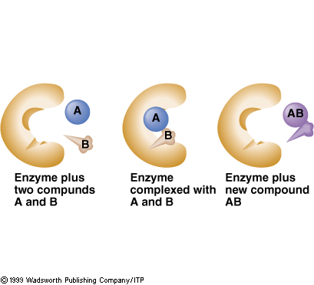

1. Hormones
   * Some hormones, but not all, are proteins
   * Hormones signal the appropriate enzymes to act.
2. Antibodies
   * Formed in response to foreign substances in the body.
   * Each antibody is specific to one foreign substance.
   * Once an antibody is made for the substance, the body develops immunity to that substance.

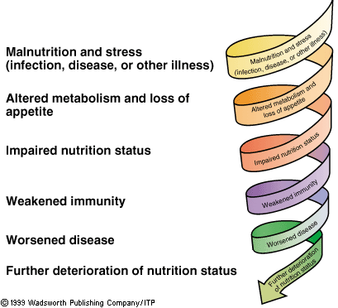

1. Fluid Balance

Fluid Balance:

* Proteins help regulate the quantity of fluids to help maintain fluid balance.
* Cells and the spaces between cells must contain a constant flux of and amount of fluid.
* Water can diffuse freely in and out of a cell; proteins can not

1. Acid-Base Balance
   * Normal body processes produce acids & bases that must be excreted
   * pH: concentration of hydrogen ions
   * Acids: release hydrogen ions
   * Bases: accept hydrogen ions
   * Acid-Base Balance: equilibrium between acids and bases in body

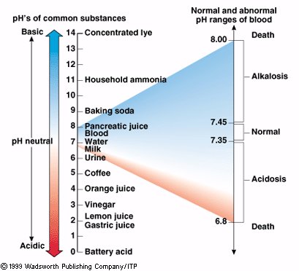

Blood proteins act as buffers for acid-base balance.

* + - Buffers: can give up or add extra hydrogen to maintain balance

Acidosis or alkalosis may occur if acid-base balance is upset

1. Transport Proteins
   * Move nutrients and other molecules in and out of cells
     + Turn on and off
     + Hormones do the switching
   * Move substances from one organ to another
     + Lipoproteins
     + Vitamins and minerals

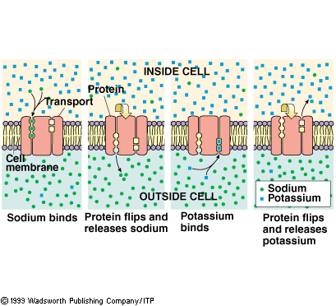

1. Energy
   * Protein may be sacrificed to provide energy if insufficient carbohydrate and fat are eaten.
   * Amino acids are degraded for energy.
   * Amino acids will only make proteins if carbs and fat are providing protein-sparing energy.
     + Protein-sparing: Leave amino acids alone to make proteins

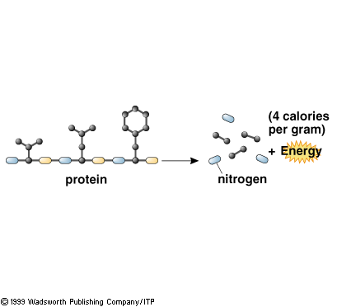

1. Contractile protein
   * Myosin – thick filaments in myofibril
   * Actin – thin filaments in myofibril
   * Dynein – cilia and flagella
2. Structural protein
   * Collagen – connective tissues
   * Elastin – ligaments
   * Fibroin – silk of cocoon, spiderwebs
   * Keratin – skin, feathers, nails, hoofs
3. Toxins
   * Diptheria toxin – bacterial toxin
   * Snake venom – enzyme that can cause hemolysis

Protein Balance

* Requirements based on nitrogen balance studies -- a balance between quality and quantity of proteins
* quality important for adequate amounts of essential AAs
* quantity important for adequate nitrogen needed for AA production
* Positive N balance: body is adding protein

N intake > N excretion

* Positive N balance important for:
  + growth/infancy/childhood
  + pregnancy/lactation
  + recovery from illness
  + athlete
* Negative N balance: body is losing protein

N intake < N excretion

* Negative N balance found in:
  + inadequate intake of protein (fasting, disease)
  + inadequate kcal intake
  + illness
  + 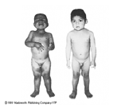immobilization
  + deficiency in essential a.a.

Protein excess

* Increased animal protein (increased fat)
* Increased risk to obesity (excess protein =body fat)
* Risk of dehydration
* Calcium loss in urine
* Possible elimination of CHO foods

Protein Deficiency Diseases: Kwashiorkor

* “the evil spirit that infects the first child when the second child is born”
* a protein deficiency
* occurs even though energy intake (calories) is adequate

Protein Deficiency Diseases: Marasmus

* protein deficiency resulting from not enough calories. The protein eaten stripped of nitrogen to be used for energy